Jorge Pires

January 15, 2019

Unit 1 | Assignment - KickStart My Chart

1. What are three conclusions we can make about Kickstarter campaigns given the provided data?
   1. Overwhelmingly, plays account for about 25% of all the Kickstarter campaigns in this dataset while 70% of those campaigns are successful.
   2. The success rate is marginal at best at about 53% while the failure or canceled campaigns amount to just under 46%.
   3. Music compiles for a 79% success rate for campaigns that have been completed.
2. What are some of the limitations of this dataset?
   1. An interesting metric for this dataset would be to see the actual count of campaign page views as it compares to the overall success rate. There were probably some campaigns could have achieved more donations if they were more visible.
   2. Live campaigns could have been excluded as these did not add any value to the analysis.
   3. The spotlight column does not provide any insight as only successful campaigns are included after the end of the campaign.
   4. Staff pick does not seem to have any correlation to the likelihood of success.
3. What are some other possible tables/graphs that we could create?
   1. A line graph of sub category vs amount pledged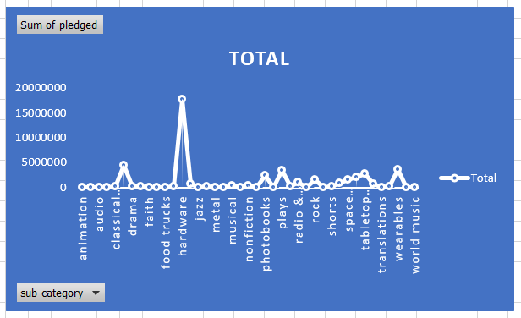
   2. Average donation vs sub category 